Jonathan Quang  
Period 2  
AP World Final Project

Economics of a Gunpowder War On Britain

A powder that when ignited, explodes and propels a bullet through the air, that is gunpowder. Such a powder needs to be improved upon endlessly. Improvements, economically speaking in wars, does not always involve making it better or cheaper. Economics in war is about manipulating supply and demand to achieve the desired goal. The supply and demand of economics is as much of a weapon as anything else as illustrated by the British in World War I.  
 Gunpowder was first invented in China for the purpose of fireworks and firing arrows. Over time, the formula for gunpowder was refined. At one point, in "How Urine Can be Used to Make Gunpowder and Other Interesting Pee Facts," Melissa Belvins states that, "Gunpowder is comprised of 75% potassium nitrate, 15% charcoal and 10% sulfur. While charcoal (historically made with wood) and sulfur (historically dug from the ground around volcanoes) have been relatively easy to obtain, potassium nitrate is not commonly found in nature," (Belvins). Charcoal is cheap, and not a worry. Sulfur is somewhat cheap, since volcanoes are not everywhere, but are easy to access. Potassium nitrate is the expensive material, only harvestable from bat guano in caves. Around the 1860s, methods of producing potassium nitrate came from having people urinate in places like public toilets, then carting off the urine to be mixed in vats of water and manure. This mixture was then filtered and dried. This was much more economically efficient, since wood, sulfur, urine, poop, and water are plentiful resources.   
 As time went on, gunpowder would be used in much greater quantities. Rifles that were breech loaded allowed quicker firing of bullets as opposed to muskets. In chapter 27 the textbook, *The Earth and Its Peoples*, it states, "In the late nineteenth century...The forces of the 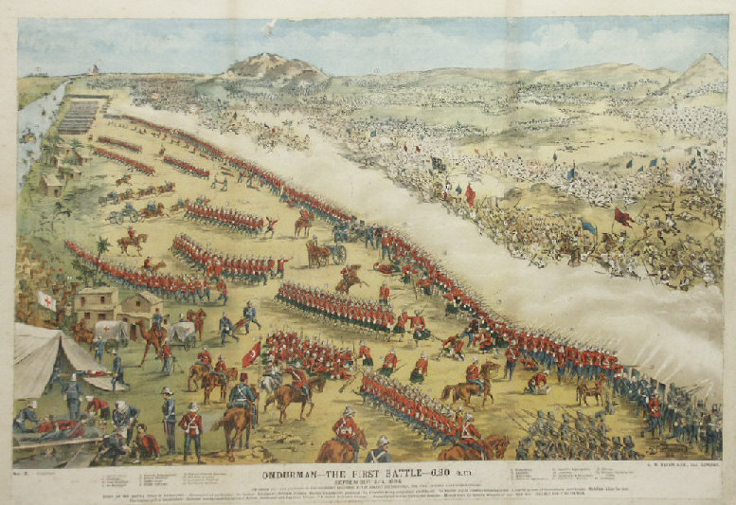Mahdi...were armed with spears and single-shot muskets. The British...used repeating rifles and machine guns able to shoot much farther than the Suadnese weapons," (Bulliet, Crossley, Headrick, Hirsch, Johnson, Northrup 775). To continue using rapid fire guns means there has to be bullets to use them. More bullet usage means more bullets have to find their way to the battlefield. By the time World War I rolled around, somebody had to pay for all this constant firing. According to chapter 28, "One country grew rich during the war: the United States. For two and a half years the United States stayed technically neutral but did a roaring business supplying France and Britain," (Bulliet et al 805). The rate of consumption of gunpowder only increases with time. Where there is war, there is a demand for gunpowder, and sometimes the supply for it is not ideal.  
 Classic gunpowder is black powder, which did not perform up to the requirements of machineguns. Black powder created residue in the chambers of machine guns and created smoke 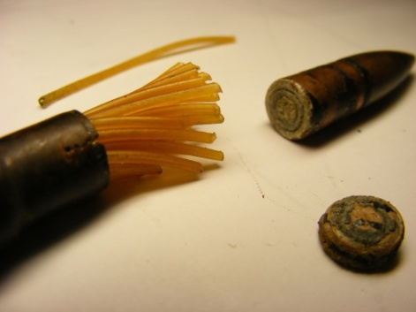that would give away positions. What people sought was a nearly smokeless powder. One such powder heavily used by the British around World War I was cordite, which looked like cords tied together. It was composed of nitroglycerine, guncotton, and petroleum jelly with acetone as a solvent. Britain's demand for acetone was high, but its supply was low. According to MacLeod and Johnson, "Before the war, acetone was derived mainly from the destructive distillation of wood, and much was imported from Austria and the United States of America," (32). By the outbreak of war in 1914, Britain had about 3200 tonnes of acetone. Supply fell short in the Shell Crisis of 1915, when the British decided to switch to a focus on attacking with shrapnel from high explosive rounds. This put a large strain on acetone supplies.   
 The scientist Chaim Weizmann had developed a method of producing acetone from starchy foods by fermenting it with a certain species of bacteria. In addition, the British created a position called Minister of Munitions to manage ammunition supplies. A new supply was created for the production of acetone, but the Germans were keen enough to attack Britain's economy by destroying trade ships with U-boats. However, the Germans did not know exactly what the food was doing beside feeding people. With a low supply of acetone, high demand for it, and no way to import starchy food, Britain began to get desperate. In October of 1917, "The appeal from [parish of] Clee St Margaret pointed out: “For every ton of horse chestnuts which are harvested, half a ton of grain can be saved for human consumption...,"' (Ellis). In a bid of desperation, the Ministry of Munitions collected horse chestnuts (called conkers) to produce acetone. This tactic had plenty of support from school children, but conspiracy theorists thought that Britain was exploiting voluntary labor since the British government would not reveal the purpose of the conkers. The British government kept the purpose a secret to prevent the Germans from finding out how their acetone was coming from food. The rumor that conkers pulled Britain out of its ammunition crisis is a commonly believed myth. This desperation ended up in somewhat of a failure because the acetone yield in a factory setting was lower than the yield in a lab with production using conkers only lasting three months.  
 While classic cordite's situation was slightly taken care of, the country had to deploy two additional measures. Britain decided to continue using classic cordite for its navy due to its stability and predictable launch force. It decided to switch to cordite RDB, which "substituted [highly nitrated] guncotton for nitrocellulose and ether-alcohol" (MacLeod and Johnson). While this method was more expensive, this was still an improvement as a different supply could be used, an economic win for Britain and they could commandeer alcohol breweries for ether-alcohol production. This decreased the livelihood of the alcohol business, but it was still strong. The third additional method was importing single-base (containing only nitrocellulose with no nitroglycerin) powders from the United States, which only made the United States richer from war.   
 To conclude, economics in a gunpowder war is a weapon. Cutting off supply is key to increasing demand and desperation in countries. The country either finds a new supply or perishes, occasionally stuffing another country's coffers.

Works Cited

Belvins, M. (2013, April 21). How Urine Can Be Used to Make Gunpowder (and Other Interesting Pee Facts). Retrieved December 28, 2015, from http://www.todayifoundout.com/index.php/2013/04/urine-facts/

Bulliet, R., Crossley, P., Headrick, D., Hirsch, S., Johnson, L., & Northrup, D. (2001). The Earth and its Peoples: A Global History (5th ed.). Boston, New York: Houghton Mifflin.

David, S. (2012, February 2). Did conkers help win the First World War? Retrieved December 28, 2015, from http://www.historyextra.com/conker

Ellis, R. (2015, October 13). Collect conkers for victory! Retrieved December 28, 2015, from http://www.shropshireremembers.org.uk/collect-conkers-for-victory/

Johnson, J., & MacLeod, R. (2006). Frontline and factory comparative perspectives on the chemical industry at war, 1914-1924. Dordrecht: Springer.